Manual Testing-
Syllabus

Manual Part-I
- SDLC(Software Development Life cycle)
- Waterfall module
- V-module
- Agile module(90% -95% used in IT company)

Types of Testing
- Sanity Testing/smoke testing
- System and functional Testing SIT Environment( System Integrated Testing)
- Retesting and Regression Testing
- UAT( User Acceptance Testing) UAT Environment

Manual Part-II
Real Part for tester ( As tester in company we are going to perform different activities like Test case design,Test case Execution,Defect,test report)

Project Management tool
JIRA, HPALM

Project
2- Projects

SQL for Tester Data base Testing
API Testing (Application Programming Interface)

Software
Basically set of program or collection of computer program, which perform set of task and software will developed by developer team based on customer requirement.
Ex-BankThey will approach IT company
CompanyAnalyse the requirement of bank and tell them budget & time.
Proposal Ok, then company will start the working over the bank requirement.
Requirement
Software Deployment
Testing
Design
Coding (Development)

Companies Service base/Product base
- ProjectBank required softwareSoftware will developed for bank customer Ex-TCS,Cognizant etc ( Service base company)
- Product Specially product is developed for market requirement
Ex-Google, IBM, Microsoft (Product base Company)

Testing
Providing quality product/software
We are insured the quality of software and defect free software. As test Engineer my objective is to provide quality service/product for customer. So we need to perform certain testing over it.
Defect/bugsome functionality is not working as per requirement or as per expected
Quality Assurance
Quality Control

QC Verify the quality of output QAProcess measuring the quality before the software deployment

Manual Testing
Testing which is performing manually on the application/software/build to check the completeness and correctness of application/software/build is called as manual testing.
Ex- Check the banking application login and password manually.

Project Team
In my team 23 peoples are there
- Delivery Manager (1)proper delivery of the requirement to the client
- Project Manager(1)Handle the team( work to be done)
- Business Analyst(1)Collect the requirement from the client
- Designer/Solution Designer(1)Architect the software
- Developer team(12-14) to write the code/ to develop the software
- Tester (QA) team (4-5) Test the software/build/application so that software should be defect free

Team size is get vary company to company but it is depends on project complexity

Support Team
It will works on ticket/issue in software ( live)
- Support manager(1)
- Developer(7-8) to change the code as per the defect /issue requirement
- Tester(2-4) to test the application is working fine or not and issue is get resolved or not

My support team size 12

SQA (Software Quality Assurance)
SQA defines the to measure and monitor the developed software/application/build
BA(Business Analyst)collect the requirement from the client & send the details to developer and tester team.
BA(Business Analyst)

Client
Tester(Team)
Developer(Team)

SQAProcessBA measure and monitor the process
- SQA will consider different kinds of parameters
BACheck
- In SQA considered the following parameters:
- Customer requirement to be full fill( Developer + Tester)
- Customer expectation (security + performance)
- Cost of the project
- Time in delivery
- Risk in project (Delivery issue or crash)

Process
- Process will decided by our company ( If client doesn’t have IT department Ex-Cred)
- Process will decided by client (If client have IT department-Ex-HSBC,SBI etc)
- Processwaterfall module, V-module, Agile module

- SDLC( Software Development Life Cycle)

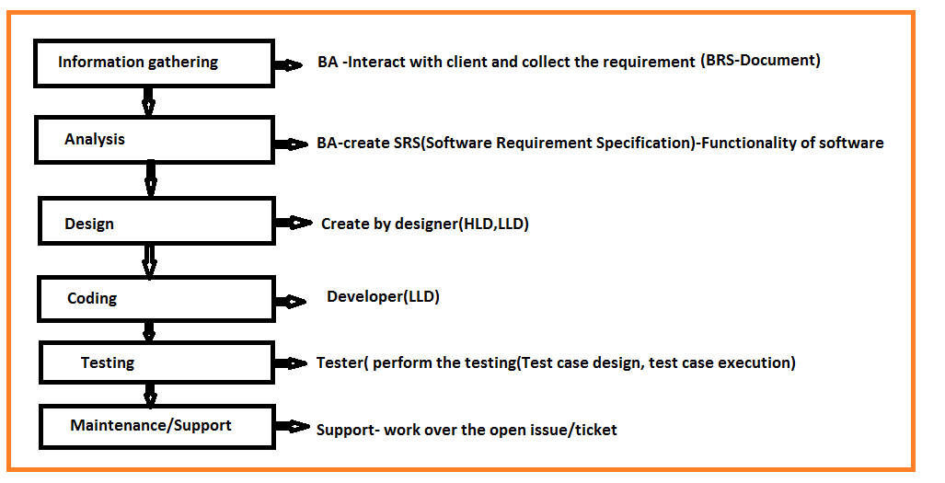

- Information Gathering( BRS Document)
- BA will collect the requirement from client
- Define the BRS document( Business Requirement Specification)
- BRStotal business requirement Platform is going to developed according requirement
- Ex-Zeroda, Upstock etc. End user will use this application use for share market activity
Buy share- 1000/-sell share-1200/-Profit=200/- Brokerage charge-100/-
Customer final profit =100/-

BA will look to develop a platform for client as per the requirement.
- Analysis ( SRS Document)
SRS Software Requirement Specification/Functional Requirement Specification/Customer Requirement Specification
SRS will derived from BRS this document will prepared by BA
SRSdefined functional requirement to be developed & system requirement
SRS will contains
- Functional RequirementAttribute which are required to be developed Ex-Login iD, password, submit button for paytm application
- Functional Flow DiagramFlow of task which we (customer) are going to perform Ex- Paytmlogin with id & passwordMobile rechargemobile no (10 digit)network select(idea,Airtel)Region(MH)recharge(amount)transations(UPI, net banking/Debit card/credit card)recharge successful message
- Use casesSingle requirement of project A)DescriptionDetails requirement about the particular use case Ex-Recharge module of paytm B)Acceptance Criteria Does and donts about the requirement Ex- Paytm For login mobile no should be 10 digit, mobile no should not be less than 10 digit
- Screen shot/snapshot/prototype BA create the prototype model for visualization of functionality before the software development( BA-use Iris software for prototype)

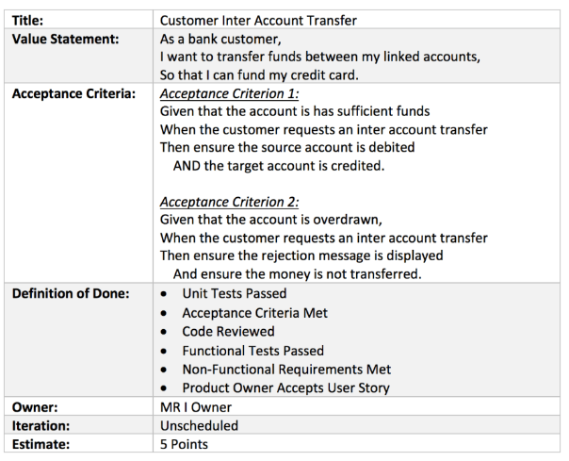
- DesignDesign prepared by designer, designer will prepared HLD&LLD
- Ex-Recharge module in PaytmHLD
1.Mobile no text box & password –textbox
2.circle selection
3.plan selection
4.payment page
5.Success message/thanks message

- CodingIn coding stages developer is working on LLD
- Ex-LLDPaytmRecharge moduleLogin IDPassword( strong-Ex-Abcd@123)-->submit buttonpaytm page openIcon need to showrecharge modulenew popuprecharge activities ( End to end functionality developmentLLD)
- Testing testing is perform by tester team when we are start the testing after the development completed and build/software deploy/send in our SIT environment. As tester test case design,test case execution.
Ex- Email Hi abc(Tester), we have completed development end to end you can start with testing in SIT environment. URl-111.123/paytm/recharge.

- Maintenance/Support Support team works on issues/current existing issues Ex-PaytmRechargeRecharge failtransaction is successful and money also deducted on that issue support team will works over the ticket raised/issue.
Questions
- What is your team size? I am working in project team and we have team size of 23 peoples are there, many people are involved in project team, I am working in testing team.
- What is SDLC?
- What do you mean by SRS/FRS/CRS document?
- When you are starts the testing? When BA prepared the SRS document and send to developer team and tester team the as tester we will start the test case design. When coding is completed and software get deployed in SIT environment then we will start the actual testing over the software.
- What is BRS, have you handle the BRS? NO
- Which technologies you are utilizing in your project? Developer. Net and for databasejava and Tester automationjava+ selenium with web driver, database testing SQL Server

Basic SDLC/ Fish module/Process

Information Gathering Analysis Design Coding Testing Support
(BRS) (SRS) (HLD,LLD) (LLD) (TCD,TCE) (Ticket/issue)

Review(BA) Review(BA) Review(Designer) WBT Testing BBT

- Static testing/ Verification / Quality control Dynamic testing / Validation / Quality assurance

Review Check the completeness and correctness of the document
TCD Test Case Design, TCE Test Case Execution

White box Testing | Black box Testing
WBT- performed by developer | BBT-performed by tester
WBT-it defines implemented application as per requirement | BBT-It defines the functionality of the application/build as per requirement
WBT- 2 Types 1.Unit Testing 2.Integration Testing | BBT-typesSanity testing,smoke testing,functional testing,regression testing
White box testing also called as code level testing | BBT also called as system & functional testing
WBT- check the logic, loop code coverage, branch coverage | BBT- check the functionality of the application ( input domain coverage,error handling coverage etc)
WBT- developer test the application only +ve way | BBT- Testertest the application both way like +ve & -ve way

Static Testing | Dynamic Testing
Static testing defines- BA checks their document, designer checks their design, developer checks their coding is called as static testing | Dynamic testing – tester check internal functionality of application/ buid is called dynamic testing
Also called as verification of application | Also called as validation of application
It is also called in progress testing | It is also called as end progress testing

Interview Questions-
- What is difference between WBT & BBT
- What is difference between static testing and dynamic testing
- What is difference between verification and validation
- Explain the fish module and how fish module is different than SDLC?

Process
Process I nothing but a regular development activities of software
Process who will decide?
- If client does not have own IT department our company will decide the process Ex-Cred
- If client have own IT department Client will decide the process Ex-HSBC, SBI
There are different types of process follows in an organization
- Waterfall module
- V-module
- Agile module( 90- 95% use)

Waterfall module
- Waterfall module is defines as sequential module of software development
- After the completion of one stage we will moves towards the next stage
- Ex-After the completion of coding we will moves towards the testing or After the completion of design step moves towards the coding
- Duration of deployment/delivery greater than 3 months ( VersionV1.0)
- If we will get defect/issue/bug Not possible to resolved in present version of software
- We can’t move back towards the previous stage
- If we will defect then it store in sheet @support send to BA defect will consider while developing next version i.e V1.1 Issue will resolved
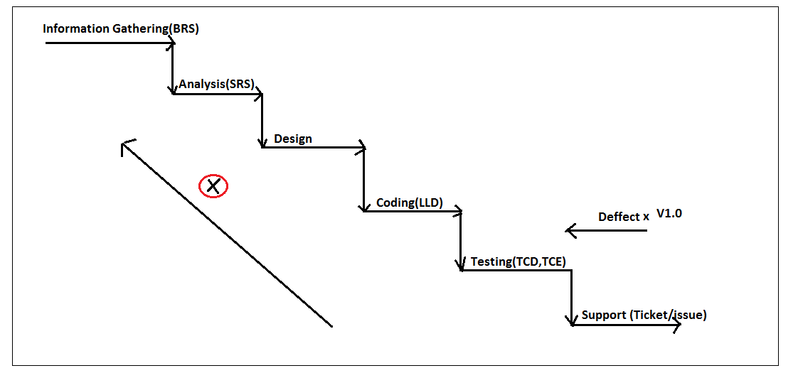
Ex- Gamming application
Drawback of waterfall module
- We can’t go to previous stage
- Delivery/deployment of software/build no fix time ( Fix time line not possible)
- We can’t accept new change request from client

V-Module
- V- stands for verification & validation
- V- module defines, it is mapping between development stage and testing stage
- V-module is nothing but plan driven process
- V-module delivery/deployment of software/build/application duration within 3 months
- V-module-parallel development & testing is going on
- V-module deals with parallel life cycle development and life cycle testing

LCD (Life cycle development) LCT (Life cycle Testing)
Information gathering (BRS) Assessment of development plane
Analysis (SRS/FRS) Prepare test plane
Requirement Testing/ Understand
Design (HLD, LLD) Design phase testing (review)
Coding (dev team-LLD) Program phase testing (WBT)
Test case design (TCD)
Install Build/ Application ( Deploy) System & Function testing (BBT) – (TCE) office
User acceptance testing (UAT) US (Client side)
Knowledge transfer (KT) Client
Maintains/ Support (Tickets) CR (Change request) /
DRE (defect removal efficiency)

TCDTest Case Design, TCE Test case Execution means testing (all functional and nonfunctional testing)
UATUser Acceptance Testing which is done at client location like-US/UK
CRChange request Ex-We have developed paytm Recharge module for mobileClient is asking for add the +91 before the mobile numbersupport team will work over
Ex- Large change request Thanks message client is asking for generate invoice link should be send over customer mobile number so that customer will see details of transactions and recharge detailsworks the Project team
DEFECT REMOVAL EFFICIENCY (DRE)=A/(A+B)
A-Defect found in BBT(Black Box Testing)
B-Defect found in UAT
DRE=1/(1+0) =1(ideal)
LimitationsDelivery/deployment in 3 months compulsory

Agile Module/Process
- It is a process of continuous development and iterative process for software development
- Agile process for software development is a value driven process( we are giving very high priority to the client)
- If any CR(change Request) comes from client then our team will check either this CR will impact over the current development or not then if not accept
- Duration of delivery/deployment in Agile 2 weeks ( 10 days) or 3 week/1 month as per company policy and project complexity
- Agile will have subtypes ( Frame work)
- Scrum ( Delivery/deployment in Sprint wise) sprint cycle=2 weeks
- Kanben ( Support)
- Lean
- XP( Xtream Programming)
- FDD( Future Driven Development)

We are working in Scrum Agile process

Agile Architecture
SDLC | Agile Methodology
1.Information gathering (BRS)  2. Analysis( SRS) Functional Requirement, Functional Flow diagram, Use case single requirement  DescriptionsDetails about requirement, Acceptance CriteriaDoes& Don’t about requirement  Prototype/snapshot/screenshot  3.DesignHLD,LLD  4.CodingLLD  5.TestingTCD,TCE  6.Support works on Ticket/issue  a)Delivery Manager  b)Client  c)Business Analyst(BA)  d)Project Manager | 1.Product Backlogn no of requirement collected from client and prepared by BA  2.Sprint backlog(in sprint 10 requirementswe will work over only 10 requirements )  Decideswhich module will take first according to client priority  User story single requirement & description and acceptance criteria  3.Design HLD,LLD  4.CodingLLD  5.TestingTCD,TCE  6.Support works on ticket/issue  a)Solution Master  b)Stake holder  c)Product Owner  d)Scrum Master

- Product BacklogIt is a total requirement for the whole project. It contains all the requirements of the all modules( Whole project)
Ex-PaytmProject Requirements=1000
- Sprint backlog Product backlog is divided in to small parts and it is known as sprint backlog, we are working on sprint backlog in sprint (2 weeks span).It contains user story description and acceptance criteria for the required module which new are developing and testing Ex-In sprint we are working over only 10 requirements out of 1000 Sprint backlog

Agile Meeting
There are 5 types of meeting we are attending
- Grooming Meeting
- Sprint Planning Meeting
- Daily Standup Meeting/Scrum Meeting
- Sprint Review Meeting
- Sprint Retrospective Meeting
Meeting Type | Purpose | Include
- Grooming Meeting  (Before Start of the Sprint) | To clear the doubts about the user story/SRS documents (Developer team & Tester team) | Meeting 30 minutes ,BA(Product Owner) Chair Person ,designer, developer team, tester team, PM(Scrum master)Optional
2.Sprint Planning Meeting ( 1st day of sprint) | 1.In current sprint how much user story will take for development & testing Product owner(BA),Scrum master(PM),Designer  2. To give the estimation( time span)decide Ex-in current sprint will take 10 US 1 user storyhow much time span will required for development & testing= dev 12hrs, testing=10 hrs | 30 minutes, Scrum Master(PM)chair person, involvesDesigner, product owner(BA), developer team, tester team
3.Daily standup/Scrum meeting (Every day) Ex- 10am to 10:15am | 1.what we have done yesterday  2.What we are going to do today  3.Issue/Roadblocks | 15 minutes. Scrum master( PM)chair person, involved Designer, product owner(BA), developer team, tester team
4.Sprint Review Meeting (Last day of Sprint) | User story(US) worked( testing)Review demo to client(Stake holder) | 1 hour, Product owner(BA)chair person,  Involvedclient(stake holder), Designer, developer team, tester team
5.Sprint Retrospective Meeting ( Last day of Sprint) | 1.Whatever we have done good things in project in current sprint  2. Whatever we have done wrong things that discussion is happened so that that mistakes (wrong things) should not be happen in next sprint. | 30 minutes, Scrum Master(PM)chair person, Designer, developer team, tester team, product owner(BA)(Optional)

Agile day wise plan
Scrum Agiledeployment duration2 week ( Monday- Friday)
Team size=23 people 5 team( Team13 developer+ 1 tester) , (Team2 2 dev+ 1tester)
……. Team5
Agile Sprint1= 20 requirement
Monday
1.Sprint planning meeting current sprinthow much US will added, time estimation
Team14 US assign to team 1( 3 developer + 1 tester)
1 US= dev-16 hr+ tester-8hr=24 hours ( 1day working =8 hrs)
Estimation1US24 hours ( 3 story points)
2US dev 8hrs + 8hrs=16 hrs

- Working start1US Developercoding ( 6 hrs) + TesterTest Case Design (5 hrs)completed
Tuesday
1.Daily standup/Scrum (15 min)issue/what we have done yesterday/what we are going to do today
1 US Dev build/software send to SIT environment
Tester1Us Test case Execution(black box testing)( 5-6 hrs) no defectTCE completed
Wednesday
Daily standup/Scrum (15 min)issue/what we have done yesterday/what we are going to do today
- Working start 2US
- DeveloperCoding (6hr)completed + TesterTCD for US-2 TCD completed(5 to 6hrs)
Thursday
Daily standup/Scrum (15 min)issue/what we have done yesterday/what we are going to do today
- Working start 2US Developer Software/build send or deploy in SIT environment
- Tester 2 US Test case Execution if defect present then raise to developer if not then OKCompleted
Friday
Daily standup/Scrum (15 min)issue/what we have done yesterday/what we are going to do today
Working start incomplete work will complete.
Developerissue resolve + Tester Retest the defect
II week (Monday to Friday)

Monday
Daily standup/Scrum (15 min)issue/what we have done yesterday/what we are going to do today
- Today planUS-3 Developercoding ( 6 hrs) incomplete + TesterTest Case Design (5 hrs)completed

Tuesday
Daily standup/Scrum (15 min)issue/what we have done yesterday/what we are going to do today
Developer works on incomplete coding
Tester Defect recheck and Regression testing (test the US1 & US2 working fine or not)

Wednesday
Daily standup/Scrum (15 min)issue/what we have done yesterday/what we are going to do today

Developer US4 will start the coding (8 hrs) 50% complete
TesterTCEUS3 Completed +
1 hr TCDUS4 (Incomplete)
Thursday
Daily standup/Scrum (15 min)issue/what we have done yesterday/what we are going to do today

Developer US4 will start the coding (8 hrs) complete deploy in SIT Environment
TesterTCD Us-4 complete the task + TCEUS4 ( complete TCE for US4)
Friday
Daily standup/Scrum (15 min)issue/what we have done yesterday/what we are going to do today
Developer documentation + deployment plan preparation
Tester one round of Regression (Testing so that all modules are working fine and there are no defect in US1,US2,US3,US4) + Traceability matrix task documentation of sprint completion
Sprint Review + Sprint Retrospective meeting

Advantages of Agile
- Sprint wise delivery/deployment(2 week)
- Daily standup/scrum meeting if team facing any issue then quickly its resolved
- Automation is possible over manual within 2 week
- Check point is present so every module will test and then moving forward
- CR or modification can implement prior checking impact over current sprint
Disadvantages
Mobile Companies like idea,jio
Recharge Module (Paytm)
Movie ticket(PVR)
- If module/project depends on another company then we can’t deliver the build within time
- If requirement is not clear before start of sprintwe can’t complete all US within 2 weeks

Agile Terminology
- Burn down chart how much work is remaining with respect to time ( Graphically represented chart)
- 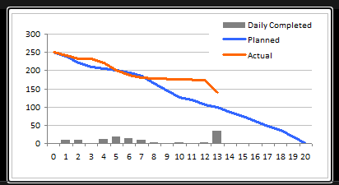
- Burn up chart how much work has been completed with respect to time ( graphically represented chart)
- 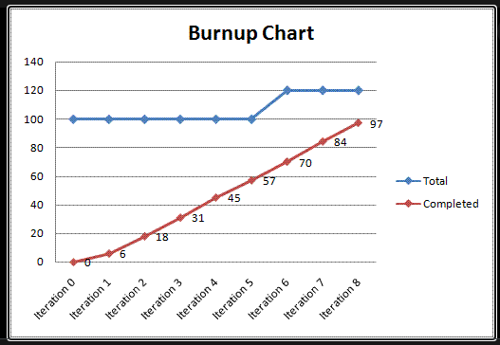
- Epic Requirement about the main module ( all user stories completed + incomplete) Ex-paytm modules Epic contains- US for recharge, US for gas booking, US for dish tv recharge ……), at time of defect raise we need to mansion Epic number of particular project
- VelocityDelivery/deployment of user story with respect to time
- 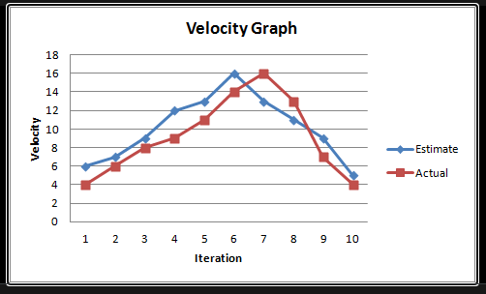

Interview Questions
1. What is difference between water fall module and V-module?
- What is the different scrum meeting in Agile or Agile ceremony?
- How Agile process is following in your organization? Explain basic of Agile then Agile day wise plan
- What you have suggested in last retrospective meeting? or what points you have discussed in last retrospective meeting? In last retrospective meeting I suggested whenever we prepared TCD while doing this discussed with developer so that Whatever we have prepared scenarios developer will see and accordingly if any scenario missed then he will prepared for missed scenario, finally number of defect in sprint will reduce.
- What are the advantages & disadvantages of Agile?
- What is Agile architecture or Agile process?
- What is burn up & burn down chart?
- What is Velocity & epic?
- Which parameter you are considering while giving the Estimation (time estimation)? Complexity of module(US) , Knowledge about the US or project, Required testing effort
- What are the disadvantages of waterfall module that recover in V-module?
- What is difference between V-module and Agile module
- What is difference between product backlog and sprint backlog?

Environments in Project
There different kind of environments is present like
- Dev Environment
- SIT Environment
- UAT Environment
- Production/live Environment
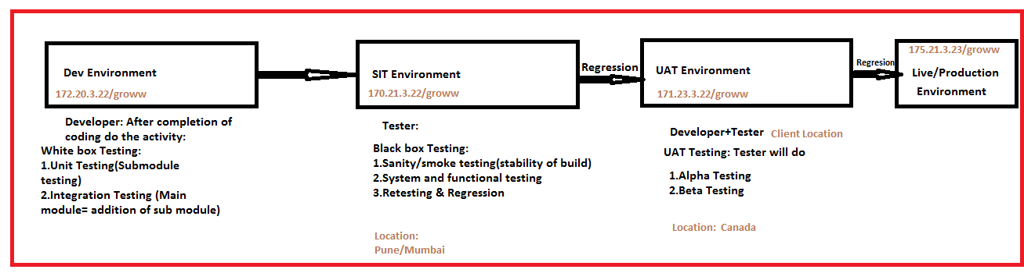

SIT Environment
Developer will deployed the build/application from Dev to SIT environmenthe will send mail and one documentUnit testing document
Mail/JIRA/HPLM message Hi xyz, we completed development and unit testing , also we have deployed build in SIT environment so you start the testing
URL for SIT- 170.21.3.22/grow

Tester SIT environment while testing the application if some functionality is not working properly as per the requirement then tester will raised the defect through JIRA application. Mail to the developer and test lead and our team. After the resolution of defect tester will do the resting & regression testing. Will update on JIRA boardtotal TCs has been passed (testing complete)

UAT After the successful completion of SIT testing build/application will deployed to UAT environment and UAT Tester will perform UAT testing over the build/application. MailSIT testing document (Execution Report) send to UAT team

Application/Project
There are different kind of testing and development projects are available with front end ,backend, data base
Backend/Server (paytm)
Web Service/API Service
Front End(GUI/UI)(Paytm)
Manual & Automation Tester

Database (SQL Server)
(paytm)
Data base Testing
Da

A)Front End Technology/languageDeveloper use. Net language.
Manual Testeruse url which sent by developer, Automation Testerjava with Selenium web driver
B)BackendserviceAPI developer used java language,
API manual Tester Postman tool, Soap UI
API Automation Testerjava with Rest Assured
C) Data baseDeveloper useSQL Server/Oracle data base
SQL servermanually SQL server, Automation java with data server

Environment Testing
There are different types of environment are present & accordingly there are several kinds of testing are performed in different environment
Dev Environment Testing Developer works in dev environmentsoftware development according to requirement and also testing also performed.
2 types of testing (White box Testing)
1. Unit Testing
2. Integration Testing
- Unit Testing
Main module
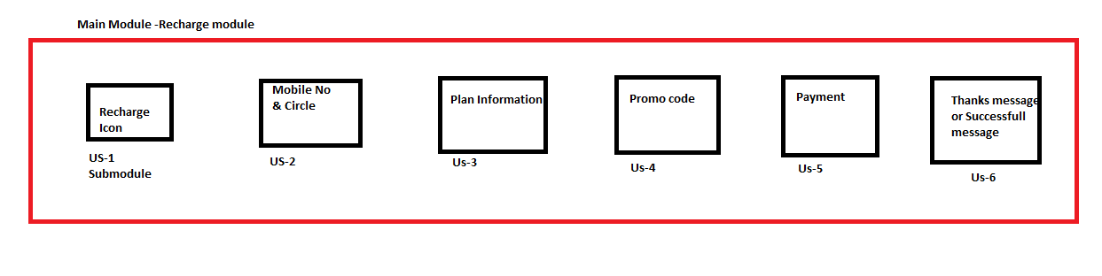
Unit Testing developer will do the unit testing on sub module review/ test the sub module is working fine or not, and after completion of unit testing developer will send the unit testing document with software/build deployment in SIT environment.
Main modulePaytm Recharge
Ex-US-1 Recharge icon Developer will do the unit testing after completion of development of Recharge icon. Review or testingParticular sub module is working properly or not.
Ex-2-Mobile No & Circle Developer will do the unit testing after completion development of Mobile no & Circle

Integration Testing
- Integration testing is performed by developer
- Integration testing is nothing but combining the all sub modules & performed the testing
- There are 2 types of integration testing 1. Front end integration testing ( all functionality testing) 2. Backend integration testing (Data base integration testing)
- Ex-PaytmFrontend integrationPaytm loginRecharge iconmobile no& circleplan infopromocodepaymentSuccessful/Thanks message
- Ex-PaytmBackend integration testingtesting using database server( SQL quiries) Validating after completion of recharge for particular mobile number is it reflecting in data base or not recharge information like date,time ,validity,transaction id, amount etc
- To perform integration testing developer apply different kind of approaches if sub modules are depends on another company and it is not completed so developer will create a temporary file for the integration testing.
Approaches
- Top down Approach
Submodule (under development)
Starting module/Main module

Temporary file ( XML file)

If sub module is not completed or under development, main module completed developer will create one temporary file(xml file Stub) and perform the integration testing.

- Bottom up Approach

Staring module/Main module( under development) Ex-recharge module
Sub module

Temperary filedriver file (xml format)

If main module is not completed or under development but submodule is ready that time developer will create temporary file it called driver file(xml format) and completed the integration testing.
- Sandwich Approach

Starting module/Main module(under development) Ex-Recharge
Middle module Ex-paytmplan info,promo code ( completed)
End module (under development)Ex-Success/thanks message

Temporary file Driver(xml)
Temporary filestub(xml)

In this approach both main module and end module are incomplete or under development but middle module is completed that time developer will create temporary file for main as well as end module and complete the integration testing.
- Tester also performed integration testing on SIT environment, after the completion of all modules Integration testing/End to end testing
- Tester will test/check the functionality of the all modules
- Developer Unit testing and Integration testing at time of build deployment from dev to SIT environment unit testing documents will provide.

Interview Questions
1.What kinds of environment present in your project? In which environment currently you are working?
2.How do you get a build? When developer performed unit testing and after the completion of that he will deployed the build from dev to SIT environment with unit testing document and url-172.10.0.20:8079/paytm
( Deployment platformOctopus/git)
3.Are you installing the build in SIT environment? No, we never installed the build/application in SIT, developer will provide url for that build.
4.Which technology/language are using in present project?
5.What do you mean by unit testing& integration testing? Have you performed integration testing? yes
6.What different kind of approaches utilizing in integration testing?

SIT Environment Testing
In SIT environment different types of testing performed like Sanity testing/smoke testing, functional testing, nonfunctional testing, retesting, regression testing
When developer will send the build to SIT environment the tester will start the testing

Sanity Testing
- Sanity testing is also called as level zero testing or tester acceptance testing
- Sanity testing is first testing performed by tester in SIT environment
- Whenever developer will send new build to SIT environment then tester will first performed the sanity testing
- We are checking the points in sanity Stability of the build for testing
- Sanity checking
- Core functionalities of the application validation Ex-PaytmRecharge module
- Validation of the link in build Ex- url-172.10.0.20:8079/paytm
- Validation of GUI ( Graphical user Interface) Ex- icon of recharge
- Validation of tab/page Ex-next page or tab opened or not
- Validation of navigation (Forward,reverse, refresh) Ex- After the recharge fail we are going to see the control is goes towards the first page or after the refresh button will moves on first page
- Ex- Build is not stableTester will test the build / test lead will test build and if observed that build is unstable/hang/run time error/system execution problem/url not working (Versionv1.0) defect raised & reject the build After the resolution of this developer will deploy the build(version v1.1) in SIT then tester will test the build and if stable then next testingBBT. While rejecting the build send the mail to the developer team and scrum master.
- Sanity testing performed by tester/test lead 2 to 3 hrs
- Build reject in Sanity testing only.

Smoke Testing
- Smoke testing is nothing but extra sake sanity testing or next version of sanity testing
- Smoke testing also called as confidence testing
- Smoke testing If we found the defect in sanitythen we will find the exact problem or issue is there so we are finding the root cause of issue
- Smoke testing= Sanity testing+Package validation( developer will do package validation)
- Ex- Paytm recharge if we want to see the sample successful recharge pdf and click over this but if pdf is not opened then need the package validation for the same issue
- Package validation developer will work on programming related to issue which has been faced
- If we found the defect in smoke testing first troubleshoot ( Root cause) + Package validation
- Smoke testing performs by team and required 2 to 3 hrs.

Sanity Testing | Smoke Testing
1.Stability of the build | 1.Troubleshoot + Package validation
2.Called as level zero testing | 2.Called as confidence testing
3.Only tester will work in sanity | 3.Tester + Developer will work on smoke testing
4.Testing core functionality like tab,page,GUI ,link (stability testing) | 4.Testing core functionality like tab,page,GUI ,link + troublesoot and package validation
5.If we found defect in sanity testing build will be reject | 5.If we found defect in smoke testing build will reject + trouble shoot and package validation

Interview Question
1.What is difference between sanity testing and smoke testing
2.What kind of testing performed in your organization( Sanity/smoke)?
3. What will be your approach when build which is deployed in SIT environment that is hanged/ login issue due to that you are not able to perform further testing?

Black box testing
- System and functional testing is also called as black box testing. When build id get stable ( sanity successful) then we will start the system and functional testing
- There are different types of System and functional testing
1.Usability Testing ( 1% to 5% follow)
2. System and functional testing ( 90% -95% follow)
3. Security Testing – ( not conducting)
4. Performance Testing

Usability Testing

- Usability testing is also called as GUI/UI testing
- Tester will validate the screen/GUI of the application
- Types of the usability testing
- A) GUI/UI Testing Validation of 1.look and feel of the application 2.Easy to use ( web element Ex-Button, tab on grow applicationmutual fund) 3.Speed of interface ( Ex- after the click on mutual fund how much time taking for response) B) Manual Support testing in this testing as tester we are validating the sensitiveness of the text ( Ex-key board click response on the text box,button, tab, web element)
- For the usability testing Test case design is required

System and Functional Testing
In the system and functional testing as tester we are validating the functionality of the build/application
There are 2 type of system and function testing
1.Functionality Testing as tester we are validating core functionality of the application with respect internal feature Ex- Groww applicationmutual fund internal feature like after the click over M.FCompany share selectiontype of investmentamountstart the SIP

2.Non functionality Testing Here we are validating the functionality of the build/application with respect external feature Ex- Groww application after the using url for the Groww application browser is opening the application

Functionality Testing as tester we are validating core functionality of the application with respect internal feature
There are different types of functionality testing (BIEBSC)
    - Behavioral coverage testing
    - Input domain coverage testing
    - Error handling coverage testing
    - Backend coverage testing/Data base testing
    - Service level coverage testing
    - Calculation base coverage testing

1.Behavioral Coverage testing
- In this testing we are validating the behavior of the object (web element)
- Validating the object/web element properly working ( behavior)

Object( Web Element) | Properties
Text box 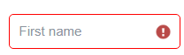 | Focused/unfocused ( Unable/disable to write)
Button | Unable/disable
Radio Button  | On/off
Check box | Clickable/not clickable
Select box/drop down 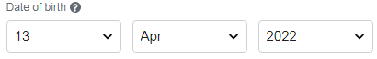 | Clickable/non clickable

2.Input domain coverage Testing

- In the input domain coverage testing, as tester validating types of input we are passing in to the object ( web element) and length of the input
- We are checking input data type and maximum and minimum length of the input
- We maintain these in to 1. Boundary value Analysis ( BVA) 2. Equivalent Class Partition (ECP) 3.Decission table technique
- 1. Boundary value Analysis ( BVA In BVA we are maintain the size & length of the input which we are passing in to object
Username
- Ex- Login page like user name
- Login page username accepting the mobile number and mail id if we are passing 10 digit mobile number that will accepted but if we will pass less than 10 digit then give the error. Email id there is particular size of string is fixed so we can give the size of input within rage only.
- 2. Equivalent Class Partition (ECP) In ECP we are maintaining the data type ( input )
- Validating the data type we are passing in to the object ex- String, integer etc..
- Ex- User name and password user name is mobile number then we can validate the mobile number with respect to data typeintegerpass. If we will take data type like char then Fail
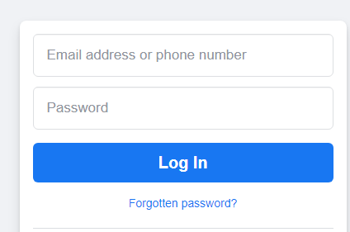
Object box | pass | fail
Mobile no | 10 digit | < 10 digit or > 10 digit
Mail id | String | char
Mail id | Symbol, int | Black/null

3.Decission table technique here we are validating the input combination which are passing in to object
- In this DTT we are checking the different kind of combination for the validation.
- Ex-Login page
Object | Rule1 | Rule2 | Rule3 | Rule4 | Rule5
User name | valid | invalid | valid | invalid | blank
Password | valid | valid | invalid | invalid | blank
login button | click | click | click | click | click
Pass/Fail | Passlogin | FailError | FailError | FailError | FailError

3.Error handling coverage testing
- As tester in error handling coverage testing we are validating the different types of error message present in the build/application
- Ex- Login page of Groww application, if we will provide wrong password then error message we get likeprovided credential either login id or password is not matching
- Ex2- if we will provide wrong information to Facebook login
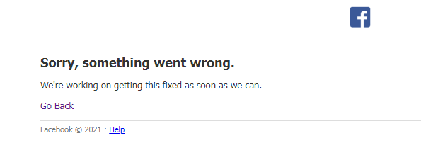

4.Backend coverage Testing/Data base Testing
- As tester here we validating the front end operation performed that stored in data base.
- In this testing we are validating different task/operation performed in front end that activity will be stored in data base we will just validate that activity stored or not stored in data base.

5.Service level Coverage Testing
- In this testing we are validating sequential flow of the application
- Ex-Paytm applicationRecharge module login credentialRechargeMobile no & circleplanpromo codepayment(debit card,credit card, internet banking, UPI)Successful message
- While doing recharge through the paytm we are validating sequence of the recharge followed by application

6.Calculation base coverage Testing
- In this testing we are validating arithmetic calculation in the application
- Particular calculation is validating either this happen according to order or not
- Ex-Paytm(Recharge module) While recharging to the mobile number if we have promo code having 10% discount thenRecharge=200/-promo code discount=20/-finally we need to pay=200-20=180/-

Non Functionality Testing
In this type of testing we are validating the core functionality of application/build with respect to external feature of the application

There are different kinds of non-functionality testing
1. Recovery Testing
2. Configuration Testing
3. Compatibility Testing
4. Installation Testing( Not performed)
5. Sanitization Testing
6. Parallelization Testing( Not performed)
7. Globalization Testing
8.Intersystem Testing

Recovery Testing
- As tester we are validating the application/build is either supporting to the abnormal situation or not.
- Ex- Abnormal situationlast payment back button presspayment process fail/ page stop
- Ex-PaytmRechargepaymentabnormal situation createdhome page will get loaded

Configuration Testing
- In this testing we are validating the hardware compatibility of the application or build
- Here we are validating either our application is configured with hardware or external device or not
- Ex-PaytmAfter the successful transactionInvoice download open in PDF Print the invoice with external device( printer)
- Ex- Groww we are buying the Tata motors share after the complete process if we want to print the transaction then we can print same activity

3. Compatibility Testing (Reliability Testing)
- In this testing ester will validate the software/application is either supporting to the client expected platform
- Client platformapplication should be run in SIT, UAT, Production environment
- Application/build is compatible with operating system and expected platform
- There 2 types of compatibility testing A) Forward Compatibility B) Backward Compatibility
- A) Forward Compatibility
OS( Error)
Build/Application

If operating system is not compatible for build then network team will work on operating system
B) Backward Compatibility
In this of testing validating the either application is compatible with browser or not
OS( Ok)
Build/Application

In the backward compatibility testing just checking the our application is compatible with different browser like –google, chrome,firefox, Ms Edge
Browser compatibility testing divided in to 2 parts 1. Cross Browser compatibility testing 2. Version control compatibility testing
- 1. Cross Browser compatibility In this testing we are validating our build/applixcation is supporting to the different browsers like Firefox, Google chrome,MS Edge, Safari ..etc
- 2. Version control compatibility testing In this testing we are validating either our build/application is supporting to the same browser with different version Ex-Groww application open in Google chrome versionVersion 100.0.4896.88 (Official Build) (32-bit) and Version 100.0.4896.89 (Official Build) (32-bit)

4. Installation Testing ( Not performed @offshore)
- In this testing tester will validate application response by installing the application on client platform
- This type of testing we are not performing offshore location(Ex-Pune/Mumbai)
- This testing performed for testing application response at client location ( Ex-US)

5. Intersystem Testing
- In testing we are validating the how our build/application is interact with different applications
- Ex-Paytm Application react with Service provided companies like Airtel, idea, BSNL,Jio while recharging the mobile
- Ex-2How paytm application is react with IRCTC while railway booking

6. Sanitization Testing
- As tester we are validating extra feature of the application/build which is not given in user story ( SRS Document)
- Extra feature is called as garbage value
- Ex-login page of PaytmUsename tester can add +91 before the mobile number and +91 it is called as garbage value
+91
- Prefix +91 added which was not present in user story

7.Parallelization Testing(Not performed)
- In this testing tester will validate the our build/application with similar different application at client location( Ex-US)
- Ex- Groww application check feature with Zeroda application and compare the functionality
- Ex- Phone pay and Google pay application feature comparison

8. Globalization Testing
- We are validating the our application/build is supporting to the different language
- There are 2 types of language 1. Standard Language English 2. Local Language own language like Marathi, Hindi, Tamil etc
- Tester does not need to learned the local language for testing

Interview Question
1.What is system & functional testing?
2.What kind of testing you have performed in your current project?
3.What do you mean by decision table technique?
4.What do you mean by BVA & ECP ? Can you write BVA& ECP for Whatsaap/phonepay?
5.What is data base testing? And which type of server you are using in your project? ServerMicrosoft SQL/ Oracle DB
6.What type of defect found in system and functional testing?
7.What is nonfunctional testing? And which type of nonfunctional testing you have performed till date?
8.What is usability testing? And explain types of same.
9.Can you give the example of calculation base coverage testing?

Retesting
- Retesting is nothing but test the application/build again after the resolution of defect
- Test the build/application with multiple test data either functionality is working properly for multiple test data or not
- Retesting we are performing in SIT environment to verify the application feature is working fine or not with multiple test data
- Ex-Login PageUser nameacceptmailid/mobile no & PasswordCombination of 4 to 6 character ( Abc@123)
- Ex-PaytmRechargeAirtel mobile no having defect @ circle selectionafter the resolution of defectretest the build/application by using multiple mobile number like –Airtel,idea,BSNL,jio..etc

Regression Testing

Regression testing performed when we will get defect and after the defect resolution we are performing regression testing as well as if our build/application is moving from one environment to another environment like SIT to UAT or UAT to live environment
- While testing we are considered the functionality of the application/build accordingly working or not
- In this testing we are confirming after the defect resolution or new functionality added in particular project either some old functionality is working fine or not
- Ex- Paytm RetestingAirtel mobile circleAfter the retesting we need to test regression and verify the another functionality of the paytm like dish tv recharge, bus booking..etc is working fine or not
- After the defect resolution or some new functionality add in project we are working on modified build
- When we are performing regression testing we will have regression suiteIncludesHigh priority TCs + failed TCs +Core functionality TCs + some remaining TCs ( Extra feature TCs)
- Regression is nothing but re-execution of the TCs with modified build or new build which is deploying to the next environment
- SIT Generally 3 to 4 hrs required for regression testing
- In Regression suite 50 to 60 TCs against the particular module

SIT environment sanity/smoke, system & functional, retesting, regression testing
After the regression testingTester will send the sign off mail after the completion of all testing in SITBuild will deployed from SIT to UAT environment (deployment through Octopus/git)

User Acceptance Testing (UAT)
- UAT also called as customer acceptance testing
- UAT will performed after the completion of SIT testing( BBT, regression)
- UATalso performed the system and functional testing
- In UAT both developer & tester are working ( client location)
- UAT having 2 types of testingA)Alpha testing B) Beta Testing
Alpha Testing | Beta Testing
Performed for web based/service based application Ex-Zeroda, Groww,Paytm..etc | Performed for product based application Ex-MS word, MS excel, MS ppt, khat book
Client locationdeveloper & tester involved | Client locationdeveloper & tester not involved
If tester found any defect then defect immediately need to assign developer and make it resolved ( Client also present) | Defectdoes not fix immediately will fix in next version ( End user involved)

Q.Have you worked in UAT in span of 3 years? Actually I have participated in UAT long back when UAT tester was on leave. In that I have performed Alpha testing through remote server and I have tested the functionality of different module than whatever I have tested in SIT environment. Ex- If In SIT there are 3 testerin case myself tester recharge module functionality in SIT and another tester tested Bus booking functionality in SIT. I have tested bus booking module in UAT testing.

Production Issue
- When our application is moving from UAT to production or live environment after the completion of UAT testing
- If defect is occur in live environment then this is called as production issue
- Production issue will be due to some reason
1.If we have missed the some functionality in testing then production issue is called as “Hot Fix”
Ex-Paytm recharge moduleplan of 4599/- is not working issue went in to live environment
Hot fix developer & tester will work on hot fix developer will check where issue is found & tester will reproduce defect and test.In this case if developer will deploy the build to the client then client apply the penlty.
2.If client has missed the some requirement/ functionality then production issue is called as “CR/RFC”
Ex-Paytm Recharge moduleplan of 599/- is not working due to client missed the recharge of 599/- in requirement.
(Company location)Hot fixImpact analysis If missed functionality is there the check the impact on current development or notif not then CR will taking for developmentCodingTestingDeployment
Client Location CR/RFCImpact analysisCodingTestingDeployment

Interview Questions
1.What is re-testing& regression testing?
2.When you found defect then which testing you will perform?
3.What is UAT and type of UAT?
4.When you have worked in UAT?
5.What is production issue?
6.Have you worked in production issue? Yes,in my organization we have worked on production issue and follows this process Production issuecheck- developertesterreproduce work.
7.What is your approach when issue/defect found in production due to functionality not tested in SIT environment? As tester I will reproduce the defect in SIT environment
1. If defect is present in SIT also I will check our test proof document ( TCD,TCE)
2. If I missed the functionality then I will inform to the developer, test lead& project manager.
3.If defect is not SIT I will inform to the developer, test lead, project manager no issue in SIT environment then developer will check deployment process
8.What is your approach when you found a issue/defect in production at last day of the sprint? In my organization at this type of scenario occurs then developer will try to fix issue on same day but if it is not fix that day then we will work on Saturday, Sunday to fix the issue and test the same.

Priority & Severity
- Priority and severity terms will define defect
- Priorityshows impact on client business and priority types are --. Very high, high, medium, low
- Severityimpact on functionality and its types are critical, high, medium and low
- Ex-Criticallogin problem called critical severity We can’t proceed further foe testing
- Examples of Priority and severity
- Example High Priority and high severityLogin page is not working ( banking login) core functionality is not working and its impact on business
- Example of High Priority & Low SeverityApplication company logo is not present
- Example of low Priority & high Severity As specific functionality is not working Ex-Downloading invoice problem
- Example of low Priority & low SeverityRearly used functionality is not working like promo code is not working
- In my organization tester decides the priority & severity of the defect ( if any changes need then test lead suggested and accordingly will changes the priority /severity)

Testing Terminology
- Monkey Testing( Gorilla testing)
- Ad-hoc Testing
- Exploratory Testing

Monkey Testing
- When we have more test cases( 60-70 TCs) & we have less time for testing (1-2 hrs only)
- Last day of the build deployment developer send the build to SIT for testing in this scenario we can approach monkey testing
- In this case we perform only core functionality of the application ( testing)
- If we found the defect in monkey testing then immediately need to resolved ( fix)and deploy again to SIT
- Whenever we will deployed the build after the monkey testing then same thing we will inform to the client

Ad-hoc Testing
- When we have less test data but we have knowledge about the application that time we will perform the ad-hoc testing
- Ex- Test the payment tab using debit card/credit card options are not available will create dummy test data like dummy credit card, debit card for testing the functionality and test the recharge like plan of 199/-, 299/-, 399/-----etc so all recharge need to take place because tester having knowledge of the recharge and payment functionality
- Temporary debit/credit card use to test the recharge

Exploratory Testing
- When we have more test data & we have less knowledge about the functionality /application that time we will perform exploratory testing
- In that testingtester itself explore ( functionalitytesting with multiple time and learned it)
- Tester itself explore knowledge about the functionality by testing again and again

Interview Questions
- What will be your approach when developer will deploy the build at last moment of the sprint ending
- What will be your approach when build is moving from SIT to UAT within 1 hrs?
- What will be your approach when your team mate is went on holiday and his US allocated to you ?
- What will be your approach when you don’t have test data for testing in SIT environment?
- What is priority & Severity give their examples.

Database Testing
In that we have different types commands are there

1.DDL ( Data Definition Language)

Commands
A)CREATE TABLE To create new table and new record insertion
Ex-CREATE TABLE TABLE1(
Name varchar (255),
Roll int);
insert into TABLE1 (
Name,Roll)
values ('Rohit','12')
insert into TABLE1 (
Name,Roll)
values ('Rohit','12')
insert into TABLE1 (
Name,Roll)
values ('Rohan','10')
B)ALTER TABLE to alter the table or to change in table structure
Ex-ALTER TABLE TABLE1
ADD MARKS int
select * from TABLE1
C) TRUNCATE TABLE use to delete the data from data base but table structure remains as it is.
Ex-TRUNCATE TABLE TABLE1
SELECT * FROM TABLE1
D) DROP TABLE Use to delete table with table structure from database
Ex- DROP TABLE TABLE1

Distinct use to retrieve unique record from data base( no duplicate record)
Ex- Select distinct * from KATRAJMARCH12

Top command Use to retrieve top record from data base
Ex- Select top 10 * from KATRAJMARCH12 will display top 10 records only from KATRAJMARCH12 table

DML ( Data Manipulation Language)

In this language we have aggregate functions Use to select statement and they will returns some numeric value
Arithmetic Operations Count(), Average(), Sum(),Max(), min() these are aggregate function use to show the particular record
- Count() Use to count the records present in the table Ex- SELECT COUNT(MOCK) FROM KATRAJMARCH12 output - SELECT SUM(MOCK) FROM KATRAJMARCH12
COUNT(MOCK)
9
- Sum()Use to add the particular records and will retrieve it Ex
SUM(MOCK)
151

- Max() use to retrieve the particular maximum numeric value from particular column of table Ex- SELECT MAX(MOCK) FROM KATRAJMARCH12
MAX(MOCK)
19
- Min() Use to retrieve the particular minimum numeric value from particular column of table Ex- SELECT MIN(MOCK) FROM KATRAJMARCH12
MIN(MOCK)
13
- Avg() Use to retrieve average of particular numeric record from the table Ex- SELECT AVG(MOCK) FROM KATRAJMARCH12
AVG(MOCK)
16.77777777777777777777777777777777777778

Logical Operator with Where clause
- Where clause is used to specify the condition while fetching the data from particular table
- AND This condition is use to retrieve the data with multiple conditions and if all conditions will satisfy then only data will retrieve Ex- select * from KATRAJMARCH12 where Fname='Ram' and LNAME='Chavan' select * from KATRAJMARCH12 where Fname='Ram' and LNAME='Chavan' AND SID='107'
- OR This condition is use to retrieve the data with or condition and if one of multiple condition is get satisfy then data will be retrieve Ex- select * from KATRAJMARCH12 where Fname='Ram' or LNAME='Salunkhe' select * from KATRAJMARCH12 where Fname='Ram' or LNAME='Salunkhe'
- NOT This condition is use to retrieve the particular data except not condition given data Ex- select * from KATRAJMARCH12 where not SID='103' All data for table will retrieve except SID=103 select * from KATRAJMARCH12 where not SID='103' AND not Fname='Kapil'

Like Clause
Like clause is used to find a value similar to the pattern given using wild card operator
wild card operator
- % ( Percentage) Use to match the one or more character from the given word Ex- select * from KATRAJMARCH12 where Fname like 'R%'
select * from KATRAJMARCH12 where Lname like 'P%' Retrieve the record starting with P
select * from KATRAJMARCH12 where Lname like '%e' Retrieve the record ending with e
- (_) Underscore use to match the particular characters Ex- select * from KATRAJMARCH12 where Lname like 'Pa__l' will retrieve last name Patil record from the DB Ex2- select * from KATRAJMARCH12 where Fname like 'K___l' will retrieve first name Kapil record from the DB
- [Charlist]% Use to retrieve the data from data base where character star with given charlist Ex- select * from KATRAJMARCH12 where Fname like '[KSR]%' will retrieve Fname start with K,S,R like Kapil,Shashi,Ram,Rashmi,Rahul,Rohit
- %Characters% Use to retrieve the record from data base where the like operator is acting in-between characters Ex- select * from KATRAJMARCH12 where Lname like '%ti%' will retrieve Last name Patil from the DB

Between
Between keyword is used to select value within given range with where clause
Ex- this keyword is use to retrieve the data of student which having mock result marks between 15 to 19
select * from KATRAJMARCH12 where MOCK BETWEEN 15 AND 19 Will retrieve the data from DB whose Mock marks between range of 15 to 19
select * from KATRAJMARCH12 where MOCK BETWEEN 13 AND 15 Will retrieve the data from DB whose Mock marks between range of 13 to 15

IN Keyword
In keyword use to retrieve the data in particular given numeric value( will Exactly match the value)
Ex- select * from KATRAJMARCH12 where MOCK IN (15,19) Data whose Mock marks are exactly 15 and 19 that records will retrieve
select * from KATRAJMARCH12 where MOCK IN (15,19,18) Data whose Mock marks are exactly 15, 18and 19 that records will retrieve
select * from KATRAJMARCH12 where MOCK IN (15) Data whose Mock marks are exactly 15 that records will retrieve

IS NULL & IS NOT NULL
Keyword/operator is used with where clause to find out the null record and not null records from the data base.
Ex-SELECT * FROM KATRAJMARCH12 WHERE MOCK IS NULL
SELECT * FROM KATRAJMARCH12 WHERE Lname IS NULL

SELECT * FROM KATRAJMARCH12 WHERE Lname IS NOT NULL
SELECT * FROM KATRAJMARCH12 WHERE MOCK IS NOT NULL

SELECT * FROM KATRAJMARCH12 WHERE MOCK IS NOT NULL AND Lname IS NOT NULL

Order by
Order by clause/statement is used to sort the record according our choice like ascending/descending order.
Ex-select * from KATRAJMARCH12 ORDER BY MOCK ASC Will retrieve the record in ascending order for MOCK column
select * from KATRAJMARCH12 ORDER BY MOCK DESC Will retrieve the record in descending order for MOCK column

SELECT * FROM KATRAJMARCH12 ORDER BY 1 DESC use to retrieve the updated record at top
select * from KATRAJMARCH12 ORDER BY Fname ASC
select top 10 * from KATRAJMARCH12 ORDER BY MOCK DESC

Aliases
Column aliases are used to make changes in column heading in our result set because of our easier to read
Ex- select SID AS StudentID from KATRAJMARCH12
select SID AS StudentID, MOCK AS MARKS, Fname AS FirstName, Lname AS LastName from KATRAJMARCH12

DML Commands

Insert RecordUse to insert the new record in existing table
Ex- INSERT INTO KATRAJMARCH12(
SID,Fname,Lname,Mobile,Mock)
VALUES('101','Rahul','Patil','9922570333','16')
Update Record Use to update the particular existing record from the table
Ex- UPDATE KATRAJMARCH12 SET SID='115' WHERE Fname='Rajan'

Delete Record Use to delete the particular row from the table
Ex- DELETE FROM KATRAJMARCH12 WHERE Fname='Rashmi'

Union/Union all Operator
It is operator used to combine the result set of 2 or more table with select statement
Union it is use to combine result set of 2 or more table with select statement and will display the unique record from the table ( duplicate record will not be display)
Ex- SELECT * FROM KATRAJMARCH UNION SELECT * FROM VIMANMARCH OutputUnique ( not duplicate)record from both table will display

Union all This operator use to combine result set of 2 or more table with select statement and will display all records from the table ( if duplicate record present then this will also display)
It will display all record with duplicate
Ex- SELECT * FROM KATRAJMARCH UNION ALL SELECT * FROM VIMANMARCH

Select into statement
Select in to statement is used to create a temporary table from existing table by copying the existing table column.

Ex- SELECT * INTO VELOCITY FROM KATRAJMARCH12
VELOCITY= Temporary table and KATRAJMARCH12= Existing table

Interview Questions
- What do you mean by DDL & DML command in SQL?
- What are syntax for update and delete statement?
- What are the different aggregate functions in SQL?
- What are wild card operator present in SQL and use of this ?
- What are the syntax for update and insert?
- Differentiate the term delete, drop and truncate?
- What are the different types of commands in SQL?
- What are the DDL,DML,DCL in SQL?
- Write a SQL query for finding the name employee who works in HR department? select name from EMPLOYEE where department=’HR’
- Write SQL query for finding the name employee who works in HR department as well as admin department? select name from EMPLOYEE where department=’HR’ and deparment=’admin’
- Write SQL query for who has getting maximum salary from employee table? SELECT name from employee where salery in(select MAX(salery) FROM employee)
- Write SQL query for getting max salary ? select MAX(salery) FROM employee
- Write SQL query for employee who’s getting salary in range of 45000/- to 50000/- ? select name from employee where salary between ‘45000’ and ‘50000’
- Write SQL query for employee record whose getting salary in range of 45000/- to 50000/- ? select * from employee where salary between ‘45000’ and ‘50000’
- Write SQL query for employee who’s getting salary in of 45000/- and 50000/- ? select name from employee where salary in (‘45000’,’50000’)
- Write SQL query for how much employee getting salary range of 30000/- to 40000/- ? select count(salary) from employee where salary between ‘30000’ and ‘40000’
- Write SQL query for how much employee getting salary of 30000/- and 40000/- ? select count(salary) from employee where salary in (‘30000’,’40000’)
- Write SQL query for how much employee getting salary of 30000/- and 40000/- and 50000 ? select count(salary) from employee where salary in (‘30000’,’40000’,’50000’)
Q. Differentiate the Drop, Truncate and Delete
Drop | Truncate | Delete
Use to delete all the with table structure | Use to delete all the but table structure remains as it | Use to delete the particular row or specific data from table
Syntax- DROP TABLE TABLENAME | TRUNCATE TABLE TABLENAME | DELETE FROM TN WHERE condition Ex- Delete from Employee where name=’xyx’
It is include in DDL | It is include in DDL | It is include in DML
Rollback/undo is not possible | Rollback/undo is not possible | Rollback/undo is possible

Table Constraints
SQL table constraint use to specify the rule for data in the table, table constraint can be used when table is created with syntaxEx-CREATE TABLE TABLENAME( Fname varchar (255) not null)
There are different types of constraints used in SQL
- NOT NULL Not null constraint force a column to accept not null data only CREATE TABLE TABLENAME( Fname varchar (255) not null)
- UNIQUE Unique constraint insure all values in column are different ( not duplicate) CREATE TABLE TABLENAME( EmployeeID varchar (255) UNIQUE)
- Primary Key It is used uniquely identifies each record in the table and it must content unique value and not null. Generally in table we are utilizing single primary key CREATE TABLE TABLENAME( EmployeeID varchar (255) primary key)
- Foreign Key This key is used to join the two or more tables together, we can use foreign key multiple times in table
- CheckIt is use to limit the value range that can be placed in a column.It allows only certain value for this column Ex-Mock marks of 20 so check constraint will be (Check(Mock mrks<20)
- Default Default constraint is used to provide default value for a column Ex-People genderdefault Male 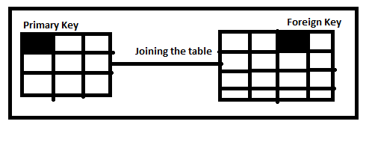
- Composite Key This is a combination of 2 or more column in the table that can used to uniquely identify the each record in the table.
(Composite key=more than 1 keys in table)
Ex- Two or more columns having unique recordEployee Id, Employee Mobilethese two columns we can called constraint is composite key
Constraint
CREATE TABLE VELOCITY1(
SID int Primary Key,
Fname varchar (255) Not Null,
MOCK int Check (MOCK<21),
MOBILE int UNIQUE,
ADRESS varchar (255) DEFAULT 'Pune')

INSERT INTO VELOCITY1(
SID,Fname,MOCK,MOBILE,ADRESS)
VALUES ('101','Ram','16','9922570433','Mumbai')

INSERT INTO VELOCITY1(
SID,Fname,MOCK,MOBILE,ADRESS)
VALUES ('102','Ramesh','14','9922270433','Pune')

Composite Key This is a combination of 2 or more column in the table that can usd to uniquely identify the each record in the table.
( Composite key=more than 1 keys in table if primary key is not there)
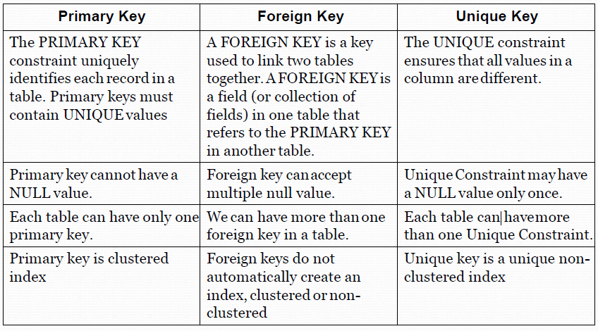

SQL join

It is use to retrieve the data from multiple table by joining the table
There are different types of join
- Left join
- Right join
- Full join
- Inner join
- Self-join

Left join
join returns all rows from the LEFT-hand table specified in the ON conditionand only those rows from the other table where the joined fields are equal (join condition is met).

Right join
This type of join returns all rows from the Right-hand table specified in the ON condition and only those rows from the other table where the joined fields are equal (join condition is met).

Full join

This type of join returns all rows from the LEFT- hand table and RIGHT-hand table with nulls in place where the join condition is not met.

Inner join
It is the most common type of join. SQL Server INNER JOINS return all rows from multiple tables where two tables contain common values in the join condition is met.

Syntax-
SELECT TN1 . CN, TN1 . CN, TN2 . CN, TN2 . CN
FROM TN1 LEFT JOIN TN2
ON TN1 . CN (Primary Key) = TN2 . CN (Foreign Key)

Ex- SELECT VELOCITY1.SID,VELOCITY1.MOCK,VELOCITY1.ADRESS,VELOCITY2.MOBILE,VELOCITY2.ROLL,VELOCITY2.RANK FROM VELOCITY1 LEFT JOIN VELOCITY2 ON VELOCITY1.SID=VELOCITY2.ROLL

  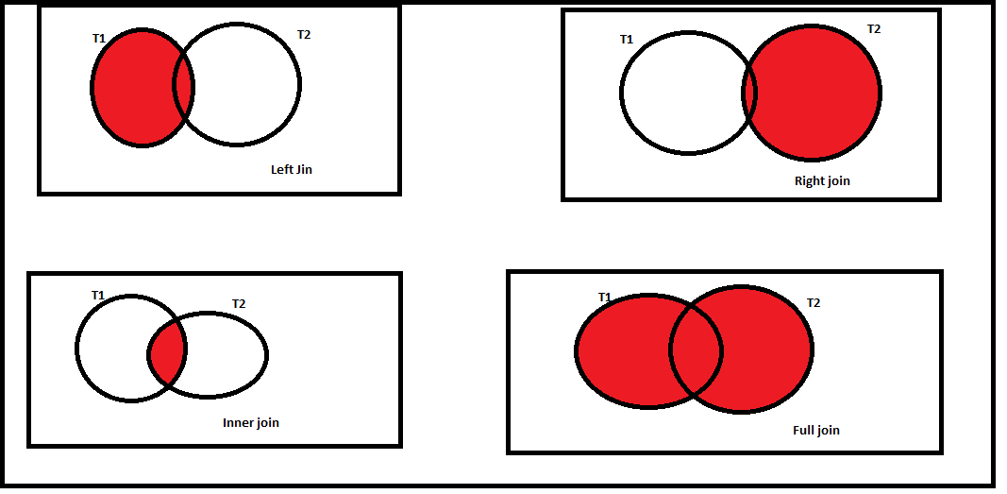

Self Join
Self join is used to combine and compare the row of the same table in the database but it may create ambiguity due to same name of the table
Ex- SELECT VELOCITY1.SID,VELOCITY1.Fname,VELOCITY1.MOBILE
FROM VELOCITY1,VELOCITY1 WHERE VELOCITY1.SID=VELOCITY1.MOBILE

Multiple joins
It is used to join the multiple tables
Ex- SELECT VELOCITY1.SID,VELOCITY1.MOCK,VELOCITY1.ADRESS,VELOCITY2.MOCK,VELOCITY2.MOBILE,VELOCITY3.MOBILE
FROM VELOCITY1 LEFT JOIN VELOCITY2 ON VELOCITY1.SID=VELOCITY2.MOBILE
LEFT JOIN VELOCITY3 ON VELOCITY2.SID=VELOCITY3.MOBILE

Group by statement
It is used with aggregate function (count,max,min,sum,avg) to group the result set by one or more column
Syntax- select MOCK,MAX(MOCK) FROM VELOCITY1 GROUP BY MOCK
select COUNT(MOCK) FROM VELOCITY1 GROUP BY MOCK
select MAX(MOCK) FROM VELOCITY1 GROUP BY MOCK
SELECT COUNT(MOCK) FROM VELOCITY2 GROUP BY MOCK

Having Clause
Having clause is used in combination with group by statement to provide specific condition
SyntaxSELECT MOCK, COUNT(MOCK) FROM VELOCITY2 GROUP BY MOCK HAVING MOCK>16

SELECT MOCK, COUNT(MOCK) FROM VELOCITY2 GROUP BY MOCK HAVING MOCK<19
SELECT MOCK, min(MOCK) FROM VELOCITY2 GROUP BY MOCK HAVING MOCK<19

View
View is virtual table based on result set of SQL statement. View contents rows,column just like real table
Query
CREATE VIEW CORPORATE AS
SELECT SID,MOBILE
FROM VELOCITY2
WHERE SID='119';

CREATE VIEW CORPORATE1 AS
SELECT *
FROM VELOCITY2
WHERE SID='119';
SELECT * FROM CORPORATE1
Index Which is used on table column, and used to retrieve the data from database more quickly than normal condition
QueryCREATE INDEX ID ON VELOCITY2(RANK)

SELECT RANK FROM VELOCITY2 WHERE RANK='14'

Store Procedure
Developer writes the store procedure for repetitive work. We can save the query and reuse again and again with help of store procedure. Query will save in store procedure and we use again by execution query.
Query
CREATE PROCEDURE CLASS
AS
SELECT * FROM velocity
GO;
Execution of Query
EXEC CLASS;

SchemaSchema is collection of DB object like triggers the store procedure. In SQL schema is list of logical structure of the data. Data base user owns the schema which has same name as DB manager.
Ex-Student table having academic record
Internal marlks internal.roll
Internal.marks
Internal.Studentname

Interview Questions
- Give the query for second highest salary from employee table? 1.SELECT MAX(SALARY) FROM EMPLOYEE WHERE SALARY<(SELECT MAX(SALARY) FROM EMPLOYEE); 2. Select min(salary) from employee where salary in(select distinct top 2 salary from employee order by salary desc)
- Give the difference between Unique key, primary key and foreign key
- What is group by statement and having clause?
- Difference between having clause and where clause
- Difference between in and between?
- Give the syntax for group by statement and having clause for employee table and salary column.
- Are you aware of insert,update,delete,ulter?
- Give the query that from employee table, employee name is start with A letter
- Give the syntax for highest salary from HR department
- Write the query for inner join,left join,right join,full join for employee1 and employee2 table
- What are the different types of join you are using in SQL for testing.

Terms related to Testing

Error Due to wrong coding we get error in application
Bug While doing the testing, if found error in the application then it is called bug
Defects When bug will accept by developer then it is called defects
Issue Critical defects/ road blocker found in the application then it is called issue

Backlog stages US/Defects/task is only present in Sprint
Ready/ In progress stage US/Defects/task is ready for development or testing / US is in progress for development or testing
Done stage US/Defects/task is completed for development or testing.
Release stage US/Defects is ready for release/deployment development or testing
Build Project/application version

==============================================================================

